Reflexive Rhyme

🔄 What is Reflexive Rhyme
# Source: Chatgpt (GPT-4-turbo) at [8/2/2025]
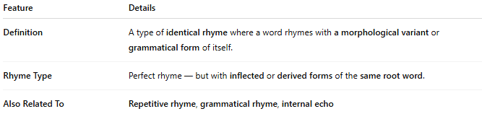
Feature | Details
Definition | A type of identical rhyme where a word rhymes with a morphological variant or grammatical form of itself.
Rhyme Type | Perfect rhyme — but with inflected or derived forms of the same root word.
Also Related To | Repetitive rhyme, grammatical rhyme, internal echo

📝 Examples:
# Source: Chatgpt (GPT-4-turbo) at [8/2/2025]
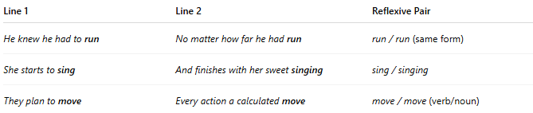
Line 1 | Line 2 | Reflexive Pair
He knew he had to run | No matter how far he had run | run / run (same form)
She starts to sing | And finishes with her sweet singing | sing / singing
They plan to move | Every action a calculated move | move / move (verb/noun)

🎭 Effect in Poetry:
# Source: Chatgpt (GPT-4-turbo) at [8/2/2025]
- Creates a mirror effect — highlighting consistency, repetition, or self-reflection
- Emphasizes key thematic words or conceptual anchors
- Adds a rhythmic and semantic loop

✅ When to Use:
# Source: Chatgpt (GPT-4-turbo) at [8/2/2025]
- When the repetition of meaning or form reinforces the message
- In poetry with themes of identity, routine, or inevitability

